**DECLARATION**

This document, named "Autonomous Car Project," is a record of our original work conducted under the supervision of Professor Pham Ngoc Nam and with the assistance and direction of teaching assistant "Truong Tuan Vu." We declare that no component has been plagiarized, with the exception of future proposals and the project background, which necessitates an examination of autonomous vehicle circumstances worldwide, from the past to the future, using trustworthy sources. This research paper is required for completion from the VinUniversity course "Introduction to CECS," which is the compulsory component of the Bachelor of Computer Science and Engineering requirements. If it is determined that the above statement is false, the university council may take immediate action.

|  |  |  |
| --- | --- | --- |
| **Student Name** | **Student ID** | **Signature** |
| Chu Dinh Bao | V202100527 | Bao |
| Do Hoang Gia Huy | V202100393 | Huy |
| Hoang Huy Minh Khoi | V202100510 | Khoi |
| Le Thanh Quoc Hung | V202100367 | Hung |
| Nguyen Tung Lam | V202100571 | Lam |

**TABLE OF CONTENTS**

**Table of Contents** 3

**Chapter 1: Introduction**

1.1 Project Definition 6

1.2 Project Objectives 6

1.3 Project Specifications 7

1.4 Applications 11

**Chapter 2: Literature Review** 12

**Chapter 3: System Design**

3.1. Design Constraint and Design Methodology

3.1.1. Design Constraints 16

3.1.2. Sustainability 16

3.1.3. Environmental 16

3.1.4. Social 16

3.1.5. Economic 16

3.2. Engineering Design standards

3.2.1. ESP-32 Main (MakerBot BANHMI Circuit) 17

3.2.2. Wi-Fi + Bluetooth Module ESP32-WROVER-IE (16MB) 17

3.2.3. Controller Area Network (CAN) Transceiver SN65HVD230 17

3.2.4. Low-power Transceiver 17

3.2.5. Servo Driver 18

3.2.6. Motor Driver 18

3.2.7. Real-time Clock 18

3.2.8. Camera ESP32-CAM 18

3.3. Theory and Theoretical Calculations 19

3.4. Product Subsystems and Selection of Components 20

3.5. Manufacturing and Assembly 21

**Chapter 4. System testing and analysis**

4.1. Camera testing 23

4.2. Manual control testing 24

4.3. Manual control while camera is sending image to computer 25

4.4. Overall testing 26

4.5. Discussion 26

**Chapter 5. Project Management**

5.1. Project Timeline 28

5.2 Contribution of Team Members 29

5.3 Project Execution Monitoring 30

5.4 Challenges and Decision Making

5.4.1. Car’s exterior 30

5.4.2. Power supply 31

5.4.3. Control system 31

5.4.4. Camera ability 31

5.5. Project Bill of Materials and Budget 32

**Chapter 6. Project Analysis**

6.1. Life-long Learning

6.1.1. Software Skills 33

6.1.2. Hardware Skills 33

6.1.3. Time Management Skills 33

6.1.4. Project Management 34

6.2. Impact of Engineering Solutions

6.2.1. Safety 34

6.2.2. Environment 34

**Chapter 7. Conclusion and Recommendation**

7.1. Conclusion 35

7.2. Future Recommendation 35

**References**  36

**Chapter 1. Introduction**

**1.1. Project Definition**

Society has witnessed the technology increasingly develop at a fast pace, and a lot of money is spent on transportation vehicles which is one of the most important aspects of many requirements of people. Autonomous cars are developed by several companies like Tesla, Audi, and VinFast, and it is vital to minimize the arising of extremely hazardous accidents due to careless people driving. It means car driving potentially becomes much easier and safer for anyone than before.

There are some conditions to meet the standard of an autonomous car:

* Capable of moving to an expected location without taking any control from human
* Able to synthesize data from numerous sources so as to perform both successful and safe autonomous driving route
* Data from a range of sensors installed on the vehicle is processed by intelligent algorithms running on the car's industrial computer system. A camera, radar, lidar, ultrasonic sensor, and several types of navigation sensors are among the sensors available. The self-driving car can distinguish between lanes, objects, bumpers, turn signals, and traffic lights using data from its sensors. As a result, it may control the steering wheel, brakes, and system signal lights on the car.

This project intends to design and produce a straightforward autonomous car that can analyze the surrounding race without any human involvement and make decisions accordingly without any human interactions. By being equipped with two or three sensors and a camera, the car can get live footage of the targeted route and utilize that to determine the accurate route. A number of sensors are combined and are used to identify the pathway and road signal from the surroundings.

**1.2. Project Objectives**

These features of autonomous cars are essential to increase the safety of daily driving and decrease the number of accidents. One of the main purposes is to shield individuals’ lives from any sort of traffic risk. Based on the previous finished tasks, our group wants to complete a self-driving automobile prototype using a toy car that will primarily navigate across a map to the finish line using computer vision and deep learning techniques:

* Usage of a compact camera to retrieve and send images to the main processing system.
* The product has to go in the middle of two dividing lines and stop at the designated destination without any influence from humans.
* The product could resolve the problem when moving out of the initially targeted road, to be specific, it could be able to change the direction a little to come back to the exact trajectory.
* Able to identify the traffic signals such as “STOP”, “TURN LEFT”, “TURN RIGHT”…., and follow the instructions accurately.

**1.3. Project Specifications**

|  |  |  |  |
| --- | --- | --- | --- |
| **No** | **Category** | **User requirements**  **(In end user’s language)** | **Engineering specification**  **(Quantitative values that can be measured)** |
| **1** | **Functional requirements (what are the functions of the product/system)** | | |
| 1.1 | Control Computer | Receive images from the camera | Receive images from the camera |
| Process the images and recognize objects | - Identify vehicles, trees, traffic signs, traffic lights, human to direct the car  - Identify single objects on the road or wall and calculate how to turn to avoid objects. |
| Send the commands to control the car | Combine inputs taken from the cameras (and/or sensors) to construct the required information in order to manage distance, manage lanes, and avoid obstacles or brakes (stop). |
| 1.2 | Self-driving | Act as the vision of the car | The camera (and/or sensors) are responsible for capturing the surrounding environments of the car and sending these inputs to the control computer.  - Camera OV7670 |
| Perform the commands from the control computer to travel to the targeted destination | After receiving the central computer’s directions, the car will perform these commands through the motors.  - MakerBot circuit:  + Features Wi-Fi, BLE, 9DOFIMU, CAN, RS485  + Sensors  + Transceivers  + Servo drivers  + Real-time clock |
| 1.3 | Errors detection | The system will report to the user if any components are malfunctioning. | - A message will be prompted on the control computer about the specific component that is not working properly.  - Detected bugs and hardware failures will be automatically sent to the server for product maintenance. |
| **2** | **Non-Functional requirements** | | |
| **2.1** | ***Performance:*** The primary operating characteristics of a product. This dimension of quality can be expressed in measurable quantities, and therefore can be ranked objectively. | | |
| 2.1.1 | Control computer | Receive images smoothly | Using Wi-Fi with stable connection to access images (Reaching 24 fps in a live 480p video stream -> engineer can see the video smoothly) |
| - Fast processing speed  - High recognition accuracy | - Each GPU is capable of 3 MB/s, and the computer can process 24 image/s  - The recognition accuracy is at least 95% |
| Fast response to give commands | Latency lower than 0.1s |
| 2.1.2 | Self-driving | High accuracy in driving | - Camera: sensing range 0-7m, data 3 MB/second  - The working frequency of the vehicle radar system is 24GHz or 77GHz. Data: 10-100KB/second |
| Fast response to perform the commands | Latency lower than 0.1s |
| Stable speed in lane | Max speed: 2.5km/hour |
| **2.2** | ***Reliability:*** The probability of a product failing or malfunctioning within a specified time period. | | |
| 2.2.1 | Battery | Less charging time, and large battery lifetime | 3.7 VDC Lithium batteries.  Charging time ~ 1.5 hours  Lifetime ~ 6 hours |
| **2.3** | ***Durability:*** A measure of the amount of use one gets from a product before it breaks down and  replacement is preferable to continued repair. Durability is a measure of product life. Durability and reliability are closely related. | | |
| 2.3.1 | Engine | Long life-time, powerful, not overheat | DC motor (5V) |
| 2.3.3 | Stability | Do not fall over at high speed | Low mass center |
| 2.3.4 | Chassis | Can protect the engine and interior from small bumps or crashes, but not heavy | 3D printing |
| 2.4 | ***Serviceability:*** Ease and time to repair after breakdown. Other issues are courtesy and competence  of repair personnel and cost and ease of repair. | | |
| 2.4.1 | Electricity and engine | Easy to repair or remove | Place maintenance features within reach  Well-organize the wire systems for removal or replacing purpose  Engine can be removed easily for maintenance |
| 2.4.2 | Battery | Less charging time, and large battery lifetime | Replaceable battery |
| **2.5** | ***Conformance:*** the degree to which a product’s design and operating characteristics meet both customer expectations and established standards. These standards include industry standards and safety and environmental standards. | | |
| 2.5.1 | Industry + Safety  (Conventional) | Offset frontal crash  (AIS – 098) | - Apply prevention systems (cameras, radars, sensors, etc.) to monitor the roadway ahead  - Apply AEB system (Automatic Emergency Braking) --> automatically apply the brakes to prevent collision or reduce severity  *- Apply Automotive airbag sensors*  *- Apply anti-drunk driving systems* |
| Pedestrian protection  (AIS – 100) |
| Side mobile deformable offset (AIS – 099) |
| Industry + Safety  (Final product) | Do no physical damage to humans | - No sharp corners  - Automatically stop when facing obstacles, especially creatures |
| No electrocution | - Well-organized electric wire  - Avoid electrical leakage --> short circuit |
| No explosion or fire | Avoid overheating battery |
| 2.5.2 | Environmental | Environmentally friendly | ***Conventional Cars:***  *1. Cars emit less than 95g of CO2/km*  *2. Produce light-duty vehicles: consume less than 4.1l/100km of petrol or 3.6l/100km of diesel* |
| ***Autonomous Car:*** *Emission-free (CO2, greenhouse gas), quieter, independent of fuels (gasoline, petrol, diesel),*  ***Manufacture:*** *reduce carbon emissions (larger demand of batteries and energy)* |
| **Product:** Recyclable materials, long lifespan battery (Lithium-ion) |
| **2.6** | ***Aesthetics:*** How a product looks, feels, sounds, tastes, and smells. The customer response in this dimension is a matter of personal judgement and individual preference. | | |
| 2.6.1 | Appearance | Elegant, delicate, no wire. | Apply available appearance and optimize the internal detail to fit with the external  (Optional) Use model cover or 3D printing cover |
| 2.6.2 | Sound and Light | Alert objects and lighting system | 1w LED – about 70-80 Lumen 0.1w siren |
| 2.6.3 | Size | Portable | 20x15x15 cm |

**1.4. Applications**

* Driving a car continuously on a long route is a challenge for drivers which causes inattention. However, car autonomation has the potential to reduce the risk and dangerous situations for drivers as AI doesn’t show any focus problems when driving. Then, an autonomous car can monitor the suitable speed for various cases while people are impossible to react punctually. Unlike humans, AI can detect the objects on the road sooner, and produce the safest solution.
* Autonomous cars can communicate together to reduce traffic congestion, for instance, when driving on the road, a car in front suddenly stops which leads to collision chains between vehicles. Moreover, autonomous cars show better performance when driving in bad weather conditions.
* Using the autonomous car is a precious opportunity for aged or disabled people to drive because everything they need to do is enter the destination for the autonomous car to transport. Automated cars can provide a considerably safer form of transportation for these folks.
* Compared to normal cars, an autonomous car can have more space for people since it doesn’t need a seat for the driver. Furthermore, as people don’t need to control the car, they can spend this driving time doing other work. It is extremely useful for businesses because they have a high burden of work and don’t want to waste their transporting time.

**Chapter 2. Literature Review**

Self-driving cars is a dream of developers for many years and many companies and individuals are taking part in its improvement day by day. The invention of self-driving automobiles has alleviated many of the challenges associated with manual driving. A simple example is that machines never go to sleep. However, creating self-driving automobiles exacerbates the challenge of large and sophisticated calculations and high-definition feature extraction. In the past, self-driving cars were equipped with complex electromechanical parts and had a long list of requirements, such as the first self-driving model proposed by General Motors in 1939, which was guided by radio-controlled electromagnetic fields generated by magnetized metal spikes embedded in the road. To operate such a vehicle, roadways must be rebuilt to include magnetized metal spikes. Then, in 1969, John McCarthy built modern autonomous vehicles based on artificial intelligence technology. John McCarthy is a researcher who described how a car may capture a raw image from the road and regulate the steering in a real-time environment using a neural network. The basic technique behind the autonomous vehicle is to sense the environment using cameras and pass this data from the computer vision algorithm and perform actions accordingly.

Self-driving cars are software-based vehicles that drive themselves. Self-driving cars are a cutting-edge technology advancement in the automotive industry that provides drivers with both comfort and safety features. Lane detection and object detection are the vehicle's basic modules. Many popular self-driving vehicles have capabilities that allow them to take control when they detect driver inattention or tiredness. Implementing lane detection can be approached in a variety of ways. The first method described by C. Ma and M. Xie in their research work is thresholding the provided image and determining left or right on the basis of white pixels. This approach warps each frame and determines which direction has the majority of the white pixels. White has a color value of 255 while black has a value of 0. In order to find the largest number of values, values for all pixels are calculated in a column-by-column manner. The side with the highest value turns that way because there are more white pixels there. This method can only be used in a controlled environment where we have a path established with white papers or similar materials. It cannot be used on roadways since we must alter threshold values for every environment, and it is not feasible at the level of commercial manufacturing. By adding additional steps after it or by employing this strategy, this method might be improved.

Before employing clever edge detection to enhance edges, Ammar N. Abbas and Muhammad Asad Irshad suggested using machine learning methods to construct a dataset of images and steering angles and train data using that dataset. By comparing each image with the path, the values of steering are predicted using the trained model. This approach cannot be used on new locations and can only anticipate a path that has already been traveled and trained in. Because it can only estimate the steering angle based on picture data, we must input every road that we use on a daily basis to train the model. Additionally, it slows things down because it must compare array training matrixes. Also, it requires a lot of data to train, therefore there is a storage loss.

Some programmers employ the Hough transformation to detect lanes. In this technique, the raw image is transformed into edges using the built-in canny method of CV2, and lines are then constructed using collinear points gathered by the HoughLinesP method and painted across the image. If we want to draw a conclusion from the information found in this literature review, we may create a model plan in which we first threshold the image to obtain a clear understanding of its edges before employing clever edge detection to detect them. Cropping the color-mapped portions of the image before thresholding is one novel feature we have included. After thresholding, canny edge detection will be used, and to remove any unnecessary edges, Gaussian blur has been used. The Hough transformation is then implemented. In order to construct lines, the Hough transform will produce information about adjacent and collinear pixels.

How the processing works in a self-driving car. It takes the raw frame that is taken at every instant and changes it to a threshold of grayscale before detecting the edges. By collecting collinear points into an array of arrays and using each array as a drawing point to draw straight lines, the Hough-lines method is used to notice edges. In Hough-Lining, orientations and the length of the line to be detected can be configured. Then the computed angle of the drawn lines is used to determine whether to draw the lines to the left or right. Not all methods calculate angles; some use color schemes while others use a comparable pixel approach.

As of now, there are some famous companies developing the autonomous cars:

**1. Tesla**

Tesla is a company that specializes in the design and production of electric vehicles. This company has a successful record in the vehicle industry, with two main functions: full self-driving and autopilot.

***Autopilot:***

* **Traffic-Aware Cruise Control**: Matches the speed of your car to that of the surrounding traffic
* **Autosteer**: Assists in steering within a clearly marked lane, and uses traffic-aware cruise control

***Full Self-Driving Capability:***

* **Navigate on Autopilot (Beta)**: Actively guides your car from a highway’s on-ramp to off-ramp, including suggesting lane changes, navigating interchanges, automatically engaging the turn signal, and taking the correct exit
* **Auto Lane Change**: Assists in moving to an adjacent lane on the highway when Autosteer is engaged
* **Autopark**: Helps automatically parallel or perpendicular park your car, with a single touch
* **Summon**: Moves your car in and out of a tight space using the mobile app or key
* **Smart Summon**: Your car will navigate more complex environments and parking spaces, maneuvering around objects as necessary to come to find you in a parking lot.
* **Traffic and Stop Sign Control (Beta)**: Identifies stop signs and traffic lights and automatically slows your car to a stop on approach, with your active supervision

**2. Waymo**

Waymo is a company that specialized in developing automobile technology. The Waymo Driver is the embodiment of fully autonomous technology that is always in control from pickup to destination. Passengers don’t even need to know how to drive. They can sit in the back seat, relax, and enjoy the ride with the Waymo Driver getting them to their destination safely.

* The Waymo Driver uses highly detailed custom maps, matched with real-time sensor data, to determine its exact road location at all times.
* The Waymo Driver's perception system takes complex data gathered from its advanced suite of sensors and deciphers what's around it through technology like machine learning - from pedestrians to cyclists, vehicles to construction, and more. The Waymo Driver also responds to signs and signals, like traffic light colors and temporary stop signs.
* The Waymo Driver takes the information it gathers in real-time, as well as the experience it has built up over its more than 20 million miles of real-world driving and more than 20 billion miles in simulation, to anticipate what other road users might do
* The Waymo Driver takes all of this information – from its highly-detailed maps to what objects are around and where they might go – and plans the best action or route to take. It instantly determines the exact trajectory, speed, lane, and steering maneuvers needed to behave safely throughout its journey.

**Chapter 3. System Design**

**3.1. Design Constraint and Design Methodology**

***3.1.1. Design Constraints***

The system design lacks in the usage of sensors, making the car over-rely on the camera as the primary source of input. However, the camera of the system suffered from immense delay, which is a critical issue to the performance of the system. The camera gets heated rapidly after a minute. At times, it was only able to capture and process the frames from 2-3 previous seconds, which is the main culprit behind leading the car off the track.

***3.1.2. Sustainability***

We may face a sustainability issue as a result of the risk of battery depletion, which will have an impact on performance. Therefore, the team also prepared three rechargeable batteries along with the provided one. We can charge it once we are finished with the task so the car can continue to work without any fear of energy depletion.

***3.1.3. Environmental***

To generate power, our model relies on batteries instead of other energy sources. Batteries can be recharged, which indicates that less battery will be used in the future owing to the recharging capability.

***3.1.4. Social***

Vehicles can be self-driving or controlled, and they can be used for a variety of tasks. Self-driving mode that works with road markers and an easy-to-use control interface with a laptop. As a result, the automobile will have a societal impact as well as several uses.

***3.1.5. Economic***

The chassis and body are 3D printed, the wheels and design are all made of plastic, reducing the cost and the installation cost is cheap and simple. In addition, the vehicle can be controlled by a computer without the need to install a controller or self-driven. Thereby, saving the cost of completing the model car.

**3.2. Engineering Design standards**

|  |  |
| --- | --- |
| Components | Engineering Standard |
| ESP-32 Main | TSMC 40nm |
| Wi-Fi + Bluetooth Module ESP32-WROVER-IE (16 MB) | IEEE 802.11 |
| CAN Transceiver SN65HVD230 | ISO 11898-2 |
| Low-power Transceiver | MAX3485 |
| Servo Driver | NXP PCA9685 |
| Motor Driver | DRV8841 |
| Real-time clock | UL |
| Camera | ISO/IEC 29151 |

***3.2.1. ESP-32 Main (MakerBot BANHMI Circuit)***

* Operating Voltage: 3.3V
* Digital I/O pins: 39
* ROM: 448 kB
* SRAM: 516 kB

***3.2.2. Wi-Fi + Bluetooth Module ESP32-WROVER-IE (16MB)***

* Wi-Fi: 802.11n @ 2.4 GHz up to 150 Mbit/s
* Bluetooth: v4.2 BR/EDR and Bluetooth Low Energy
* Operating Voltage: 3.0V - 3.6V

***3.2.3. Controller Area Network (CAN) Transceiver SN65HVD230***

* Operating Voltage: 3.3V
* Recommended Supply Voltage: 3V-3.6V
* Recommended Input Voltage: 0-3.6V
* Low Current Standby Mode: 370μA Typical
* Data Rates: 1Mbps

***3.2.4. Low-power Transceiver***

* Operating Voltage: 3.3V
* Transmission Rate: 10Mbps
* Max Skew: 8ns
* Common-Mode Input Voltage: - 7V-+12V
* Allows up to 32 Transceivers on the Bus
* Industry Standard 75176 Pinout

***3.2.5. Servo Driver***

* Operating Voltage (range): 2.3V-5.5V
* 5.5V tolerant inputs
* Dimensions (no headers or terminal block) 2.5" x 1" x 0.1" (62.5mm x 25.4mm x 3mm)
* Weight (with 3x4 headers & terminal block): 9g
* PWM Frequency: 24Hz-1526Hz
* 4096 steps (12-bit PWM) of individual LED brightness control
* Supports asynchronous control of the LED outputs

***3.2.6. Motor Driver***

* Operating Supply Voltage (range): 8.2V-45.0V
* Operating Supply Current: 10μA-20μA
* Rise Time: 30-200ns
* Fall Time: 30-200ns
* Maximum Drive Current at 24V and 25°C Operating Ambient Temperature: 2.5A

***3.2.7. Real-time Clock***

* Supply Voltage: 2.3V-5.5V
* Integrated microelectromechanical systems resonator for long-term accuracy
* Timekeeping Accuracy: ±5ppm
* I²C interface: 400kHz
* Operating Temperature: –45oC to 85oC

***3.2.8. Camera ESP32-CAM***

* SPI Flash: Default 32Mbit
* RAM: internal 520Kb + external 4Mb PSRAM
* I/O ports: 9
* Bluetooth: 4.2 BR/EDR and BLE standards
* Wi-Fi: 802.11
* Power Supply: 5V
* Operating Temperature: -20 °C - 85 °C

**3.3. Theory and Theoretical Calculations**

In order to for the car to follow the path without being led off the track. The system needs to detect edges to identify the moving lane of the car. As a result, the control computer would be able to send signals for the car to stay in the center of the path. For this purpose, we follow the Canny algorithm, which was developed in 1986 by John F. Canny. The algorithm is used to detect edges for an image. It operates with the following steps:

* Step 1: Reduce the noise of the input image

A Gaussian filter is convolved with the image to remove the image. The Gaussian filter kernel of size (2k+1) * (2k+1) is represented by the following formula:

Where:

* x is the distance with the origin in the horizontal axis
* y is the distance with the origin in the vertical axis
* is the standard deviation of the Gaussian distribution
* Step 2: Calculate the Intensity gradient of the image

Calculate the edge gradient and direction from the gradient vector:

Gradient Vector

Edge Gradient

Direction

* Step 3: Suppress the non-max edge contributor pixel points

If the point (x,y) has the largest the largest gradient of edge. Then, check every edge point perpendicular to the edge and check if their gradient is smaller than (x,y). In other words, a point is only kept if it is the local maxima, otherwise it is adjusted to be 0.

* Step 4: Hysteresis Thresholding

Every point that has a gradient intensity larger than the high threshold would be considered as edge pixels. On the other hand, those with gradient intensity lower than the low threshold would be considered non-edge pixels. The remaining pixels would be edge pixels if they are connected or next to an edge pixel, while those not connected would be skipped.

In order to transform the input images into bird’s-eye view in order to more accurately identify the lane of the car. This transformation is made with Perspective Transformation:

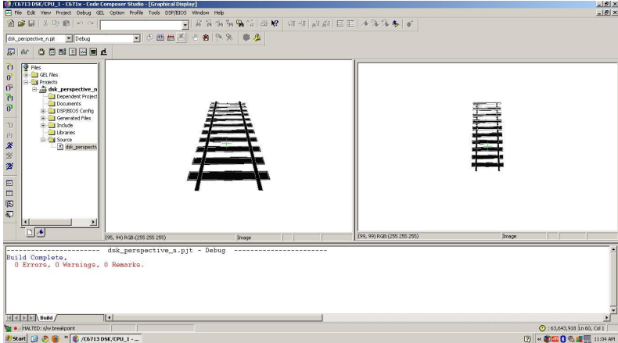

Figure 1. A demonstration of bird’s-eye perspective. Adapted from “Transformation Technique” by M. Ventakesh & P. Vijayakumar, 2012, *Journal of Sciences and Engineering Research, 5*(3).

**3.4. Product Subsystems and Selection of Components**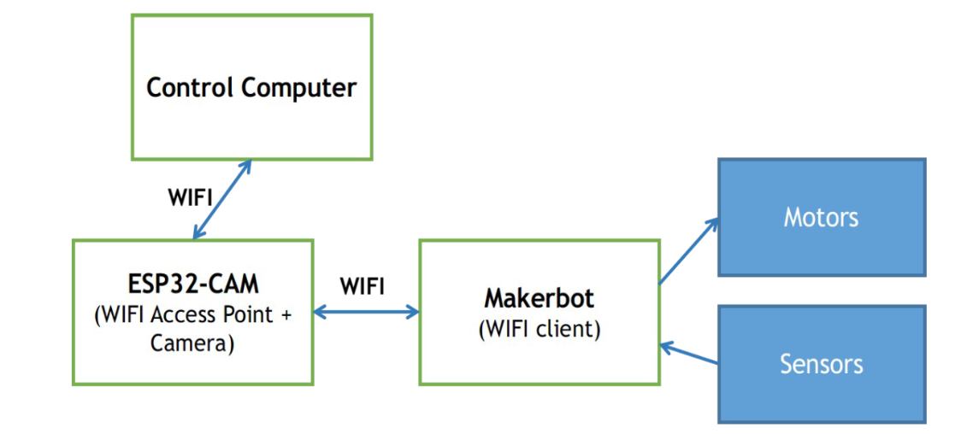

Figure 2. Diagram of the system with communication method

There are three main components for the system: control computer, ESP32-CAM, and the MakerBot board. They are connected to one another via Wi-Fi. In the beginning, the camera will capture and process the images and send them back to the control computer over its Wi-Fi channel. The algorithm of the control computer will then process the images and output commands for the MakerBot to run its motors and sensors accordingly.

Selection of components:

* Material of the chassis: PLA plastic
* Material of the cover: PLA plastic
* Camera: ESP32-CAM
* Mainboard: MakerBot BANHMI circuit
* 2 Motors: Robot V1 66mm
* Battery: 3.7V 2000mAh Lithium-Polymer LiPo Rechargeable Battery 103450 with Connectors and 3 18650 Lithium-ion Rechargeable Batteries
* 2 Tires: Rubber tires with modifications.
* 2 Swivel caster wheels

**3.5. Manufacturing and Assembly**

Starting with the model, the architecture was generated using CAD and produced using a 3D printer.  Second, Arduino can take camera inputs, analyze them, and output them so the automobile may move. The camera would be linked to a Bluetooth sensor, allowing us to monitor live images. We changed the RGB to grayscale to hasten the conversion process. The engine and wheel, which make up the third component, move the robot. We 3D print the chassis, the cover, and handle using CAD software (SOLIDWORKS). We raised the camera above the automobile to give it a better view. Furthermore, we have a sensor on the car's wing that can track the road's white line. Finally, we utilize a battery to power the vehicle.

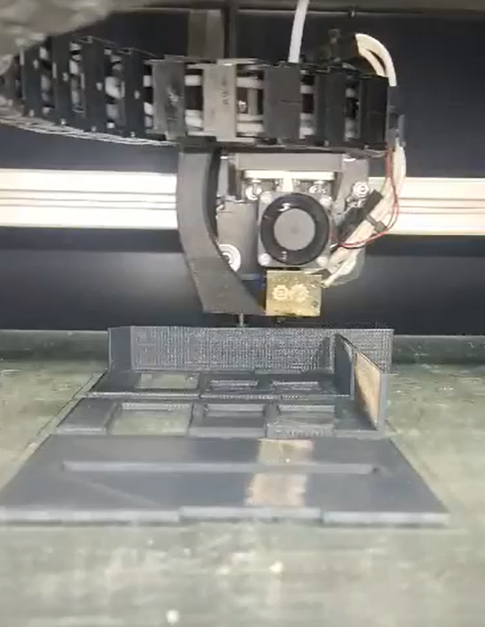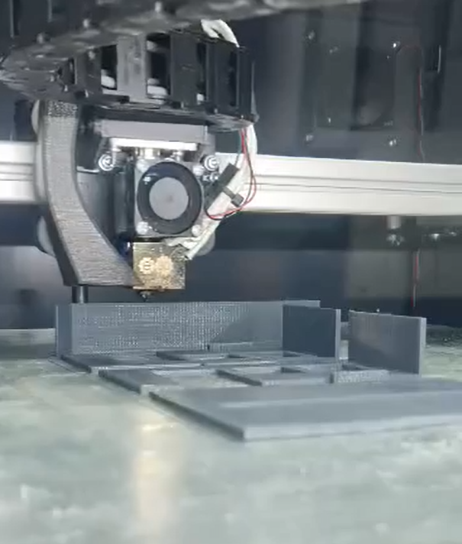

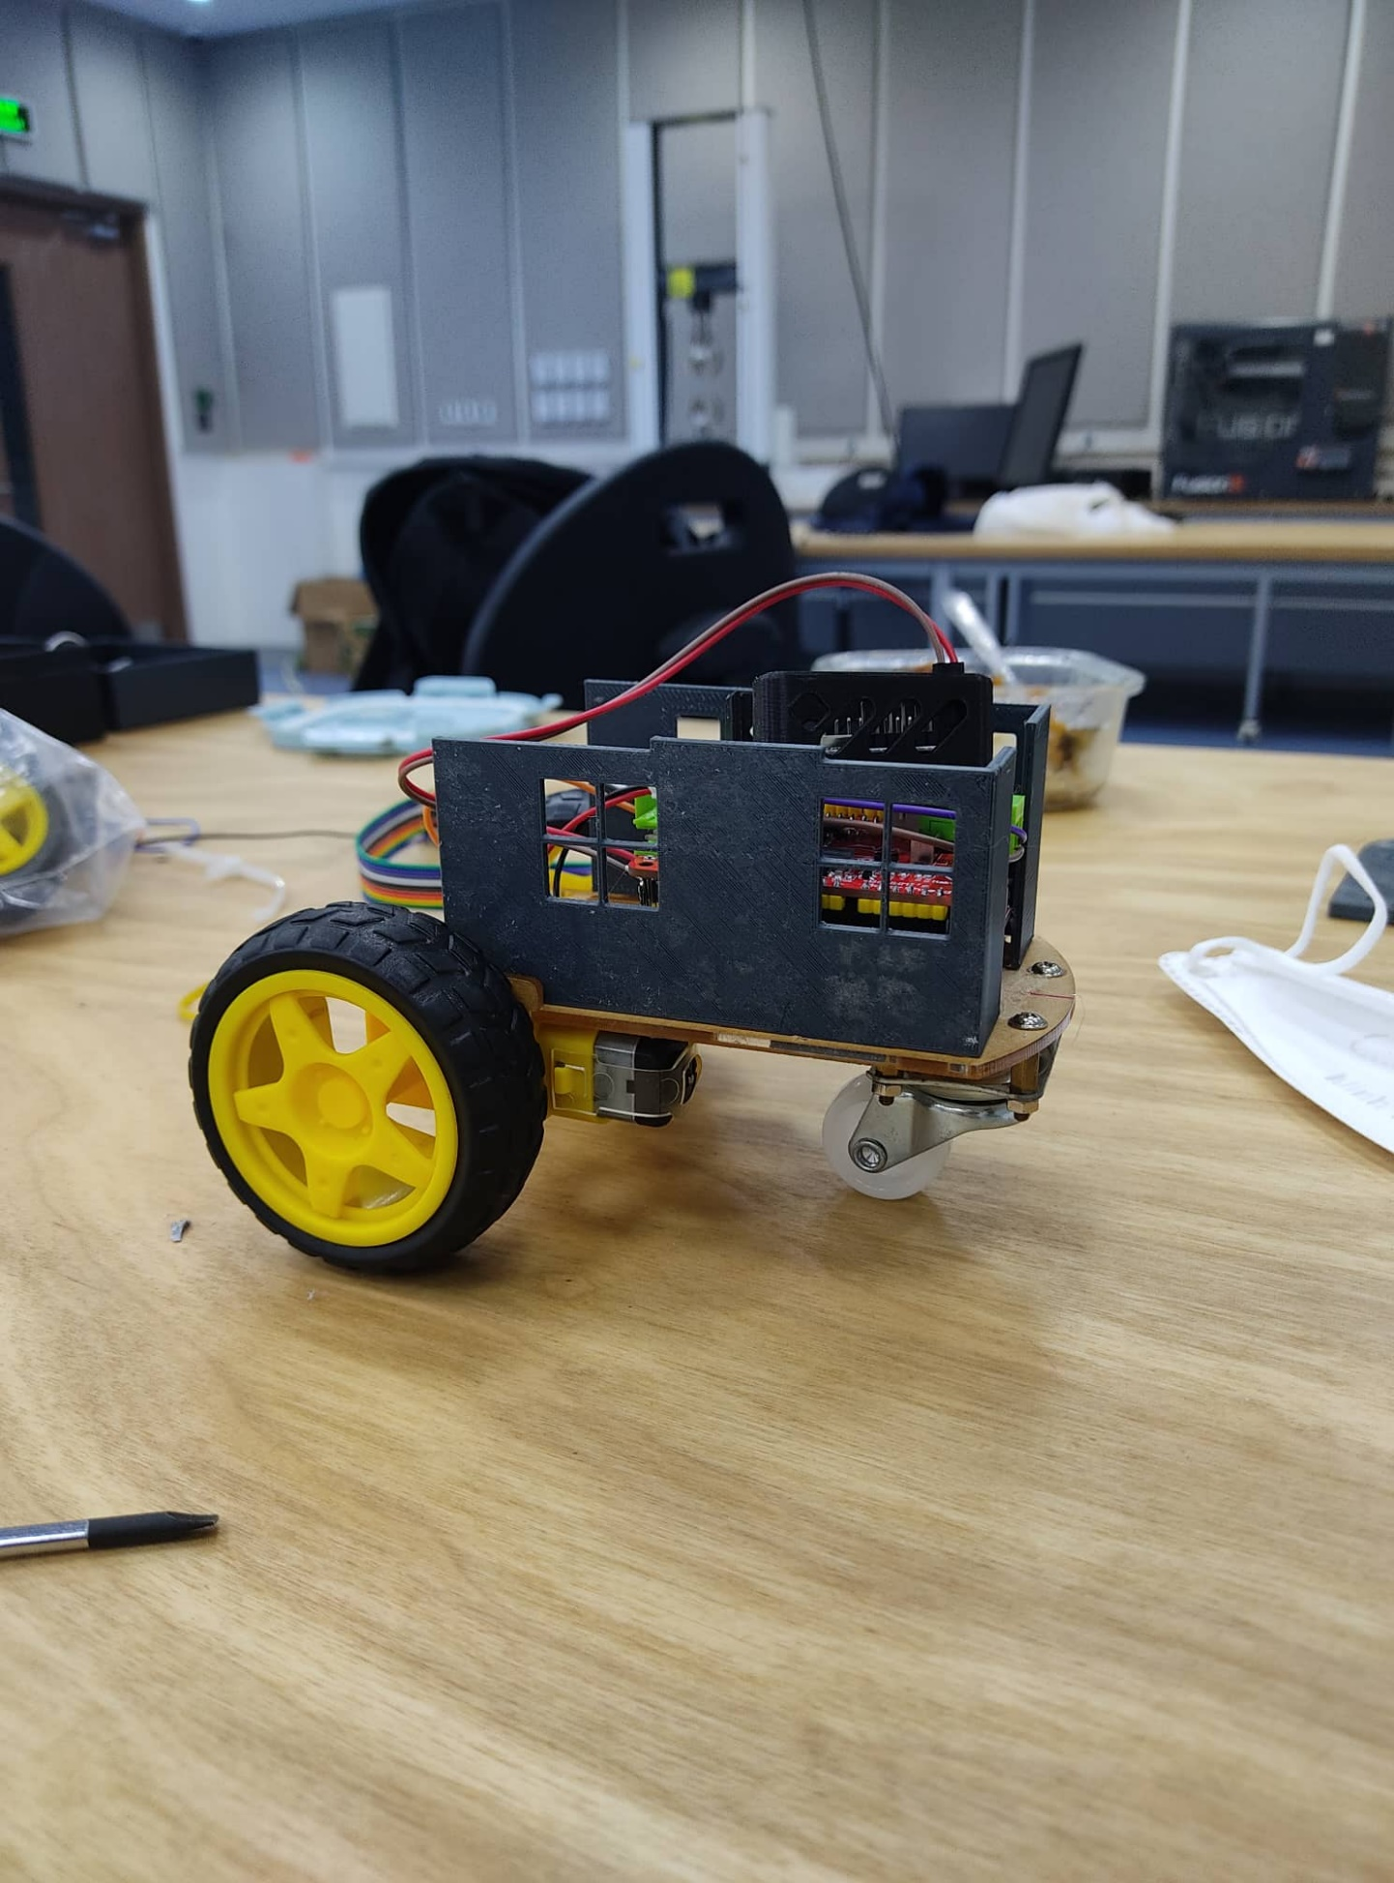

**Chapter 4. System testing and analysis**

**4.1. Camera testing**

***Objective:***

* Make sure that the ESP32 camera can take the video and send data back to the MCU through integrated Wi-Fi

***Set-up:***

* ESP32 camera was powered by the MCU.
* The specified Wi-Fi connection was initialized by the ESP32 module, and our computer joined to that network to keep track.

***Result:***

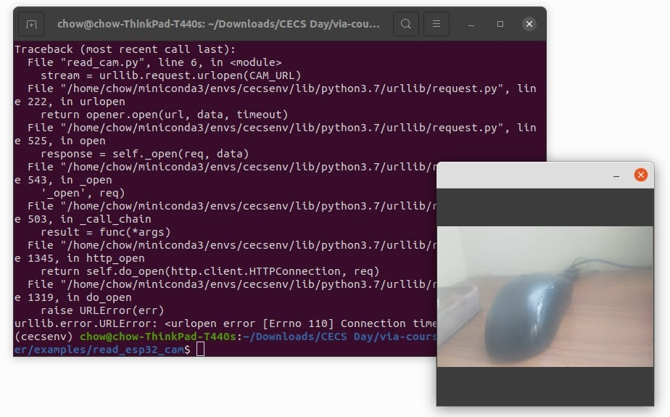

* The camera worked well and sent real-time video to the computer with a low latency.
* The ESP32 module’s temperature was not high.
* The local port was not affected by the other team’s connection.

**4.2. Manual control testing**

***Objective:***

* Testing the car driving system, car’s chassis, and the communication between car and computer.

***Set-up:***

* Both car and computer joined to the Wi-Fi connection initialized by ESP32 module.
* The manual driving command (WASD) was sent directly from the computer to the car.

***Result:***

* The car worked well with low latency
* Temperatures of both ESP32 module and MCU were low
* The car chassis was strong enough to move at the preferred speed.

**4.3. Manual control while camera is sending image to computer**

***Objective:***

* Test the camera and manual driving at the same time to check the performance and temperature of each component.

***Set-up:***

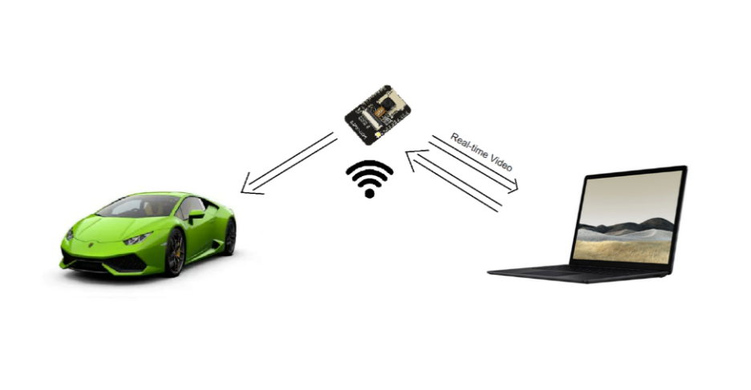

* Camera and computer joined to the WiFi connection initialized by ESP32 module
* The real-time video from ESP32 module was sent to the computer
* The manual driving command was sent from the computer to the car.

***Result:***

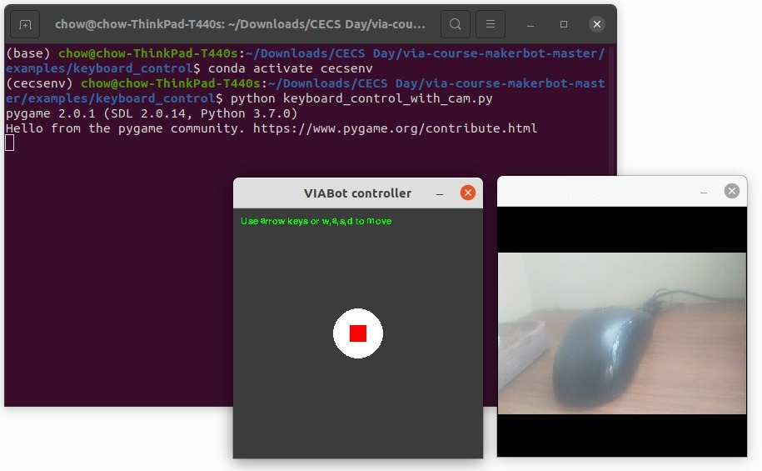

* Camera and car worked with high latency
* Each component’s temperature was higher than the previous test.

**4.4. Overall testing**

***Objective:***

* Testing the car and making sure that every component will cooperate well together.

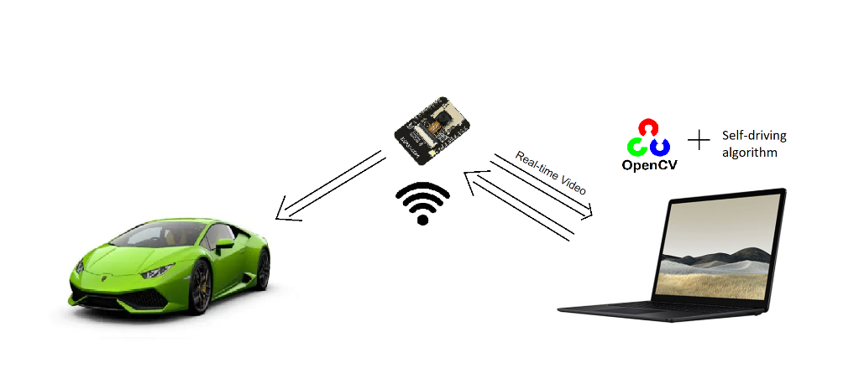***Set-up:***

* Car and Computer joined to the same Wi-Fi connection initialized by the ESP32 module
* The grayscale video was sent from ESP32 camera to the computer and processed by OpenCV to detect the line and traffic signal.
* Self-driving algorithms used the OpenCV result to generate the driving command.
* Driving command was sent to the car through WIFI connection.

***Result:***

* Car worked well at the first time. However, after a short time, there is a high latency, and the car cannot response to the current line, even if we set the delay time to 1s.
* ESP32 module was really hot, and the system crashed frequently.
* It was not easy to capture the line and traffic signal at the same time.

**4.5. Discussion**

* Each component worked well individually, and the video signal was processed on time.
* However, when we tested the system, there were more problems, the ESP32 module became hotter, and we could not control the car.
* We tried two types of line detection: 2 lines following and 1 line following, and we have the result:
  + The 2-line following guides the car to the center of the road and gives us more accuracy and stable movement.
  + In one line following, the car was guided to follow one lane side (in our case is right side) and it will minimize the workload and data transfer, but it is hard to work in the corner.
* Our biggest problem is temperature and performance of ESP32 module, in this contest, we tried to solve it by changing the system connection to some other types:
  + The Wi-Fi hotspot will be created by the other Wi-Fi module, instead of the ESP32 camera, such as the mobile phone’s hotspot or Wi-Fi modem.
  + The control command will be sent to the car by Bluetooth module instead of Wi-Fi
  + Sending command through the cable and USB port
* If we have more time and resources, we will improve:
* Change the car-computer connection to a more stable one, instead of ESP32 module’s Wi-Fi as we did in this contest.
* Improve the Wi-Fi antenna for ESP32 module.
* Add other sensors to this car, such as line tracking sensors, or one more camera to detect the traffic signal.
* Improve the radiators for each component.
* Optimize our driving algorithms.
* Improve the driving system, replace the current front wheel by another multiple-direction wheel.
* Improve the chassis and cover, make it stronger and lighter.

**Chapter 5. Project Management**

**5.1. Project Timeline**

In the early stages of the project implementation, we planned and divided the work and timeline for the members. However, due to the postponement of CECS day, we also had to change our plans to accommodate the new schedule. Our plan is shown in the task table below:

|  |  |  |  |  |  |
| --- | --- | --- | --- | --- | --- |
| **Stages** | **Task** | | **Start** | **End** | **Duration** |
| 1 | Requirement Specifications | Descriptions of computer functions and model car functions | 10/10/2021 | 20/10/2021 | 10 days |
| Descriptions of non-functional requirements |
| 2 | Develop plan | | 1/11/2021 | 15/11/2021 | 14 days |
| 3 | Design each block | Analyze the given task requirements | 16/11/2021 | 24/11/2021 | 8 days |
| Conduct detailed design with alternatives for each part of the system | 24/11/2021 | 26/11/2021 | 2 days |
| 4 | Design and select best alternative for Block 1 (Car Model – External Part) | Determine the optimized car design structure | 26/12/2021 | 10/1/2022 | 14 days |
| Test the car design |
| Choose the final alternatives |
| 5 | Design and select best alternative for Block 2 (Control system – Internal Part) | Determine the optimized control system |
| Test the control system |
| Choose the final alternatives |
| 6 | Research and determine the potential materials | | 28/3/2022 | 4/4/2022 | 8 days |
| 7 | Create first chassis | Materials and components for chassis. | 5/4/2022 | 7/4/2022 | 2 days |
| First chassis | 8/4/2022 | 10/4/2022 | 2 days |
| 8 | Testing | Control program testing | 11/4/2022 | 25/4/2022 | 14 days |
| Prototype testing |
| 9 | Manufacture | Produce final control system and program | 25/4/2022 | 29/4/2022 | 4 days |
| Produce final chassis | 2/5/2022 | 6/5/2022 | 4 days |
| 10 | Deliver | Presentation | 7/5/2022 | 7/5/2022 | 1 day |
| Process report | 15/5/2022 | 1/6/2022 | 16 days |
| Product paper | 16/6/2022 | 22/6/2022 | 6 days |

**5.2 Contribution of Team Members**

Team members are divided into work clearly and specifically, they clearly understand nature of their work and duties. Members actively participate in discussions, give opinions, and at the same time complete assigned tasks on time carefully. The members' contributions to each task

are shown in the table below:

|  |  |  |  |  |
| --- | --- | --- | --- | --- |
| **Stages** | **Task** | | **Assigned Members** | **Contribution** |
| 1 | Requirement Specifications | Descriptions of computer functions and model car functions | Everyone | 100% |
| Descriptions of non-functional requirements | Everyone | 100% |
| 2 | Develop plan | | Everyone | 100% |
| 3 | Design each block | Analyze the given task requirements | Everyone | 100% |
| Conduct detailed design with alternatives for each part of the system | Everyone | 100% |
| 4 | Design and select best alternative for Block 1 (Car Model) | Determine the optimized car design structure | Minh Khoi  Tung Lam | 100% |
| Test the car design |
| Choose the final alternatives |
| 5 | Design and select best alternative for Block 2 (Control system) | Determine the optimized control system | Dinh Bao  Quoc Hung  Gia Huy | 100% |
| Test the control system |
| Choose the final alternatives |
| 6 | Research and determine the potential materials | | Minh Khoi | 100% |
| 7 | Create first chassis | Materials and components for chassis. | Tung Lam | 100% |
| First chassis | Minh Khoi | 100% |
| 8 | Testing | Control program testing | Dinh Bao  Quoc Hung  Gia Huy | 100% |
| Prototype testing |
| 9 | Manufacture | Produce final control system and program | Dinh Bao  Quoc Hung  Gia Huy | 100% |
| Produce final chassis | Minh Khoi  Tung Lam | 100% |
| 10 | Deliver | Presentation | Everyone | 100% |
| Process report | Everyone | 100% |
| Product paper | Everyone | 100% |

**5.3 Project Execution Monitoring**

During the course of the project, we often have meetings between members and a few meetings with professors to ask for advice on our products. At the same time, we also have a few important milestones marking the progress of the project. This is shown in the table below:

|  |  |
| --- | --- |
| **Date** | **Events** |
| Friday (Week 1, 3, 5, 7, 9) | Project Lecture |
| Weekly | Group meeting |
| 15/4/2022 | Completing the first prototype |
| 20/4/2022 | Test the prototype |
| 6/5/2022 | Completing the final product |
| 7/5/2022 | CECS Day |
| 22/6/2022 | Submitting the Final report |

**5.4 Challenges and Decision Making**

***5.4.1. Car’s exterior***

Our team decided to create the car’s exterior by ourselves to have the most suitable chassis. In details, we use SOLIDWORKS to sketch the design and utilize 3D printer “Fusion3 F410” and supporting tools “Simplify3D” to print out the prototype. However, in real life, there are various limitations for instance the non-optimal position of the camera, the flexibility of the wheels, chassis, and camera. Therefore, the procedure had to be repeated many times until getting the feasible final product.

***5.4.2. Power supply***

During testing, we observed that the battery drained fairly quickly while using the provided battery, which may have an impact on performance of the car model. Thus, we attached a self-construct battery system with lithium batteries and fix it at the end of the model. To be more specific, this approach will increase the model’s mass, yet it does also expand the working duration of the car. In general, this measure worked quite successfully.

***5.4.3. Control system***

Initially, we had to review and modify the provided code, which was a challenging task. We devoted a great deal of effort to comprehending and modifying the code, but after applying it to the car, we learned that this method has a drawback: the latency of the network connection causes the automobile's decision to turn, significantly slowed down (caused the car to quickly deviate from the back road into the turn and the furthest distance traveled by the car was very different after each attempt). In addition, in order to enhance the coding for self-driving cars, we provide the vehicle with a manual driving mode as a backup in case it cannot operate autonomously on the presentation day.

***5.4.4. Camera ability***

During the testing, due to the inadequate camera quality, we found out that it easily went overheat during a short amount of progressing time, thus, impacting negatively to the processing capability of the whole car. However, due to the lack of time, we decided to let the camera take a rest after each 15 minutes testing. Eventually, this approach did not work very well at all at the presentation day.

**5.5. Project Bill of Materials and Budget**

|  |  |
| --- | --- |
| **Component (quantity)** | **Cost (VND)** |
| Camera (1) | Given |
| Motor (2) | Given |
| Wheel (2) | Given |
| Wires | Given |
| Lithium batteries (3) | 135.000 |

**Chapter 6. Project Analysis**

**6.1. Life-long Learning**

The arduous project will culminate our technical knowledge and soft skills. Throughout the project, our team has acquired a wealth of knowledge and critical abilities that will surely have long-term benefits. As a result of the project's devotion to fundamental abilities, such as teamwork and communication, we were able to improve our personal ability significantly.

***6.1.1. Software Skills***

Due to the nature of our project, which required the construction of a vehicle with specified parameters, we had to rely heavily on computer programs learned during the previous semester in order to successfully complete the project. Firstly, by using SOLIDWORKS as well as some self-learned experience about 3D printer, we designed the exterior part of the model with creative and simple appearance. Secondly, we did also utilize Python and Arduino software to create the control system of the car, especially the motors’ speed, sensor or Wi-Fi technology.

***6.1.2. Hardware Skills***

Beside the software skills, the procedure of building a car model did cultivate our hardware skills. Some notable parts include Arduino Uno, sensors, Wi-Fi ship, or Lithium battery. To be more specific, we had to feasibly integrate the required components (according to the specification) to maximize the capability of the car, for instance, ultrasonic sensor to detect objects, line tracking sensor to orient the model along a predetermined path. Additionally, we had to dispose all the elements (Ex: Bluetooth, Wi-Fi, camera, etc.) plausibly for better circuit system connecting with battery.

***6.1.3. Time Management Skills***

In order to complete this tough project on time, time management played an essential role. During the project, our team had learnt to use various team and time management techniques and software, for example, Microsoft Teams and Gantt Chart. In details, Gantt chart allowed us to outline all the milestone of the project, distribute the assignment and track the progression effectively. In general, this tool not only supported us in complete the tasks promptly but also an effective platform to communicate with professors and advisors.

***6.1.4. Project Management***

We required a project management approach to ensure that the project remained on schedule. We began by appointing a project leader who would serve as the team's representative. The team members shared the responsibilities. Some tasks were to be accomplished independently, while others were to be completed in groups. We had nearly weekly meetings with the members and monthly meetings with the advisor. This is in addition to the standard weekly email communication. All participants contributed to the project's fundamental responsibilities, which included developing and constructing the prototype as well as doing research and writing the report.

**6.2. Impact of Engineering Solutions**

***6.2.1. Safety***

Our project's objective is to limit the danger of contamination to technicians and eliminate human mistake. For example, we rely on human labor and expose a large number of individuals to hazardous chemicals and other things, putting their lives at danger. Where none of these difficulties will be encountered by the robotic car.

***6.2.2. Environment***

Regarding the environmental qualities, we ensured that the battery is rechargeable, so reducing the reliance on fuel. Therefore, there will be no carbon footprint; instead, the majority of materials utilized are recyclable. This prototype can function for up to 2 hours and travel roughly 2 kilometers. Nevertheless, we are confident that as technology continues to advance, both time and distance will be doubled.

**Chapter 7. Conclusion and Recommendation**

**7.1. Conclusion**

It is important to learn from every design, project, and business. Learn from your mistakes to make advancements and achieve perfection. Working on this project together was incredibly enjoyable, where everyone could improve their communication and teamwork skills. At the beginning of this project, collaboration was challenging, nonetheless, we were increasingly accustomed to working as a team as time passed. This project utilized all we had learnt in engineering classes, ranging from electrical components to sketching our design in SolidWorks and implementing code with Python. We assured that our robot has sufficient torque in order for it to operate effectively and without problems. In conclusion, working as a team is a great deal of joyfulness and will ultimately benefit us all. It was rewarding to develop a fully functional project from simple notions to a complex design.

**7.2. Future Recommendation**

We devised a large number of strategies to help us better our project. However, the majority of these concepts need significant financial investment, which has been a challenge for us. Due of Bluetooth's and Wi-Fi’s limited range, we intended to employ wireless instead of Bluetooth for our robot. Due to a shortage of resources, we encountered into issues while working on Wi-Fi. We decided immediately that we didn't want a simple design, and we would recommend that anyone working on a senior design do the same. Additionally, when we first begin our project, we exert the most effort to perform a comprehensive study in order to organize our ideas. Moreover, we always complete tasks in a group and discuss our ideas. One more thing, before commencing our hands-on work, ensure that all of our ideas are documented. Finally, ensure our 3D model is aesthetic and simple.

**References**

Armaghan, H. M. (2021, January 1). Self-driving car project report. Academia.edu - Share research. <https://www.academia.edu/50173066/Self_driving_car_project_report>

Espressif. (2022). Wi-Fi & Bluetooth MCUs and AIoT Solutions I Espressif Systems. <https://www.espressif.com/sites/default/files/documentation/esp32-wrover-e_esp32-wrover-ie_datasheet_en.pdf>

Maxim Integrated.<https://datasheets.maximintegrated.com/en/ds/MAX3483-MAX3491.pdf>

Maxim Integrated. (n.d.). DS3231M. <https://datasheets.maximintegrated.com/en/ds/DS3231M.pdf>

Mushtaq, A. (2019). Prototype of a self-driving car Safi ud din final year project report. Academia.edu - Share research. <https://www.academia.edu/42692061/Prototype_of_a_Self_Driving_Car_Safi_ud_Din_Final_Year_Project_Report>

NXP. (2015, April 16). 16-channel, 12-bit PWM Fm+ I2C-bus LED controller. <https://cdn-shop.adafruit.com/datasheets/PCA9685.pdf>

Tesla. (2021, June 15). Autopilot and full self-driving capability. Electric Cars, Solar & Clean Energy | Tesla. <https://www.tesla.com/support/autopilot>

Texas Instruments. (n.d.). DRV8841 Dual H-Bridge Driver IC. Analog | Embedded processing | Semiconductor company | TI.com. <https://www.ti.com/lit/ds/symlink/drv8841.pdf?ts=1655863924289&ref_url=https%253A%252F%252Fwww.google.com%252F>

Towards AI Team. (2020, September 18). What is a Canny edge detection algorithm? Towards AI. <https://towardsai.net/p/computer-vision/what-is-a-canny-edge-detection-algorithm>

Ventakesh, M. & Vijayakumar, P. (2012, May). Transformation Technique. *International Journal of Scientific & Engineering Research, 3*(5)*.* [*https://www.ijser.org/researchpaper/A-Simple-Birds-Eye-View-Transformation-Technique.pdf*](https://www.ijser.org/researchpaper/A-Simple-Birds-Eye-View-Transformation-Technique.pdf)

Waymo. (2022). Waymo driver. <https://waymo.com/waymo-driver/>